
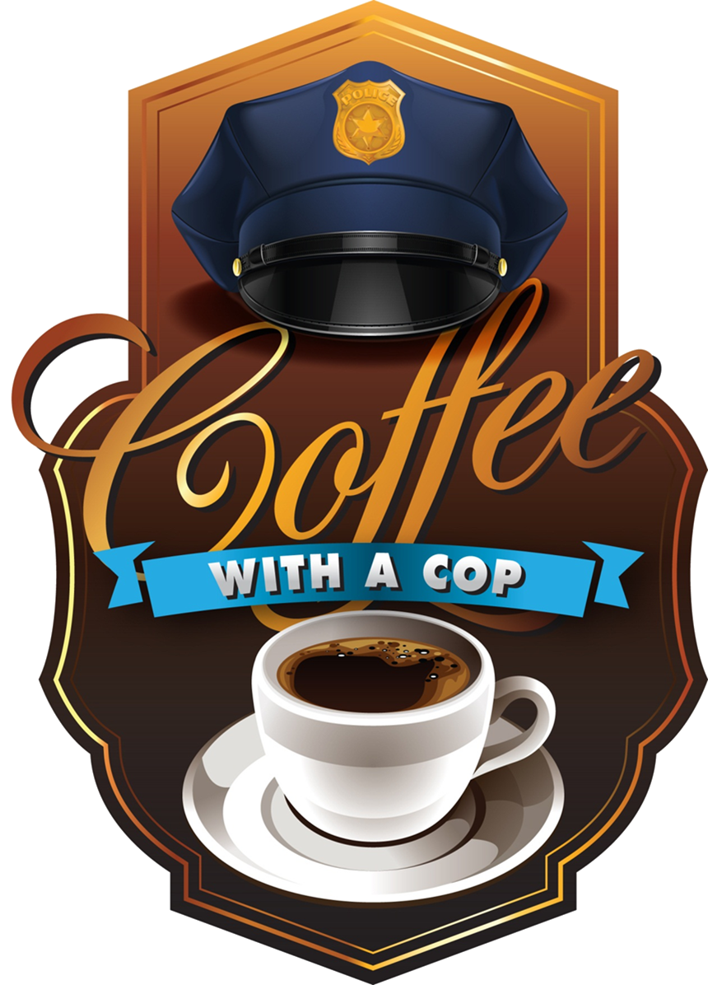
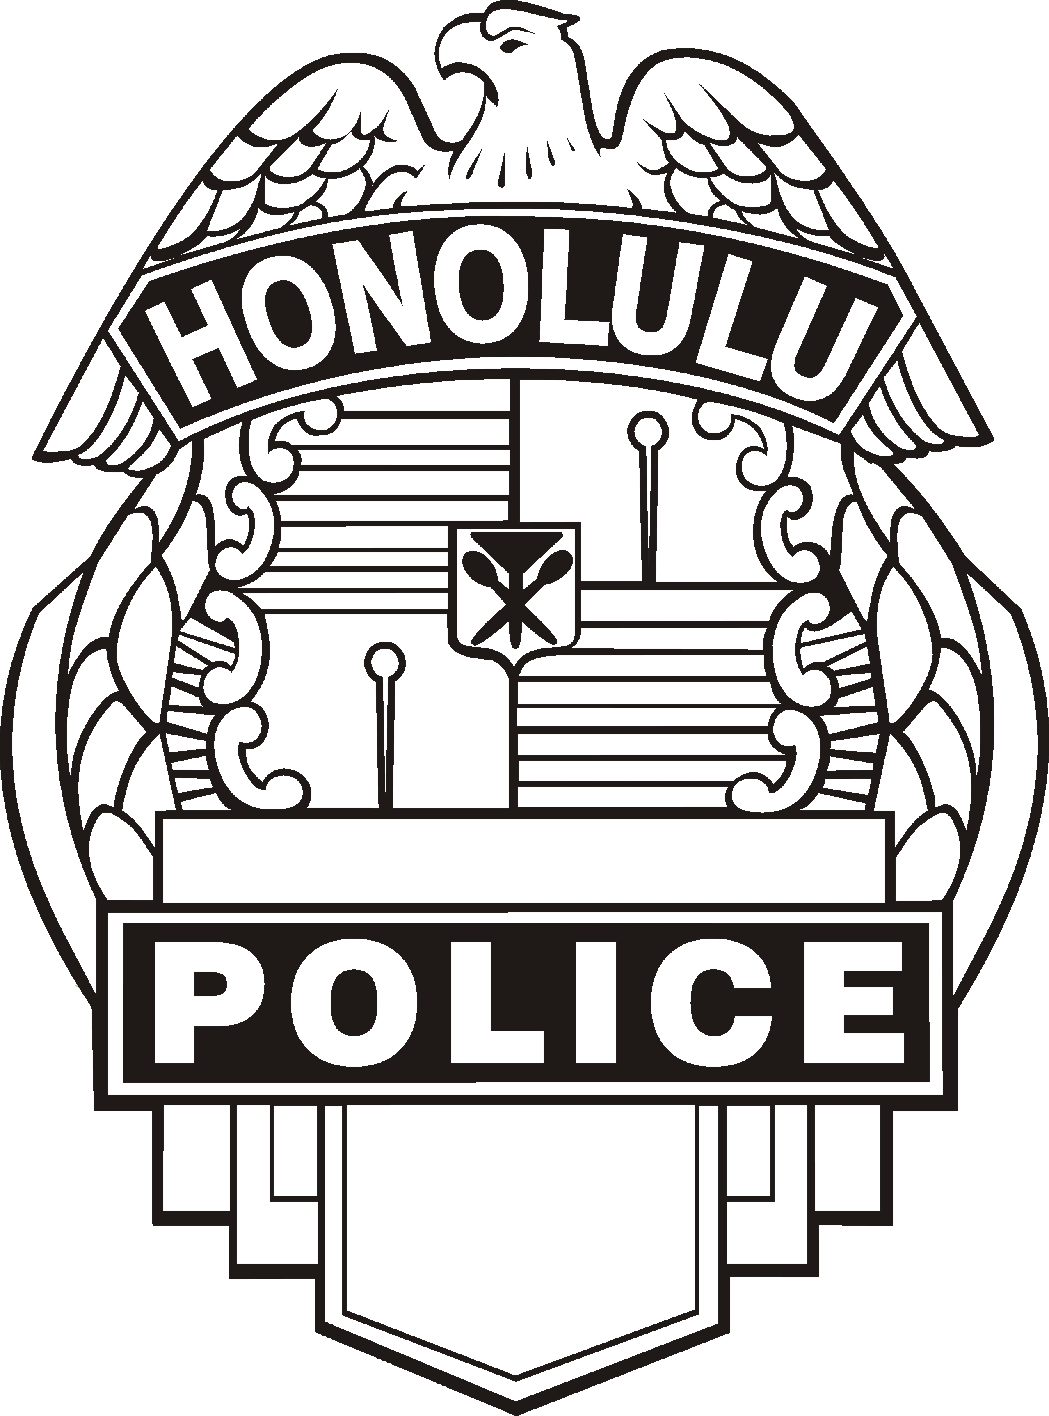
Friday
November 19, 2021
9 a.m. to 11 a.m.

Windward City McDonalds
45-480 Kaneohe Bay Drive
For more information please call Officer Jarret Atkins at 723-8876.
JOIN YOUR NEIGHBORS AND POLICE OFFICERS FOR COFFEE AND CONVERSATION!
No agenda or speeches, just a chance to ask questions, voice concerns, and get to know the officers in your neighborhood!

HONOLULU POLICE
DEPARTMENT

