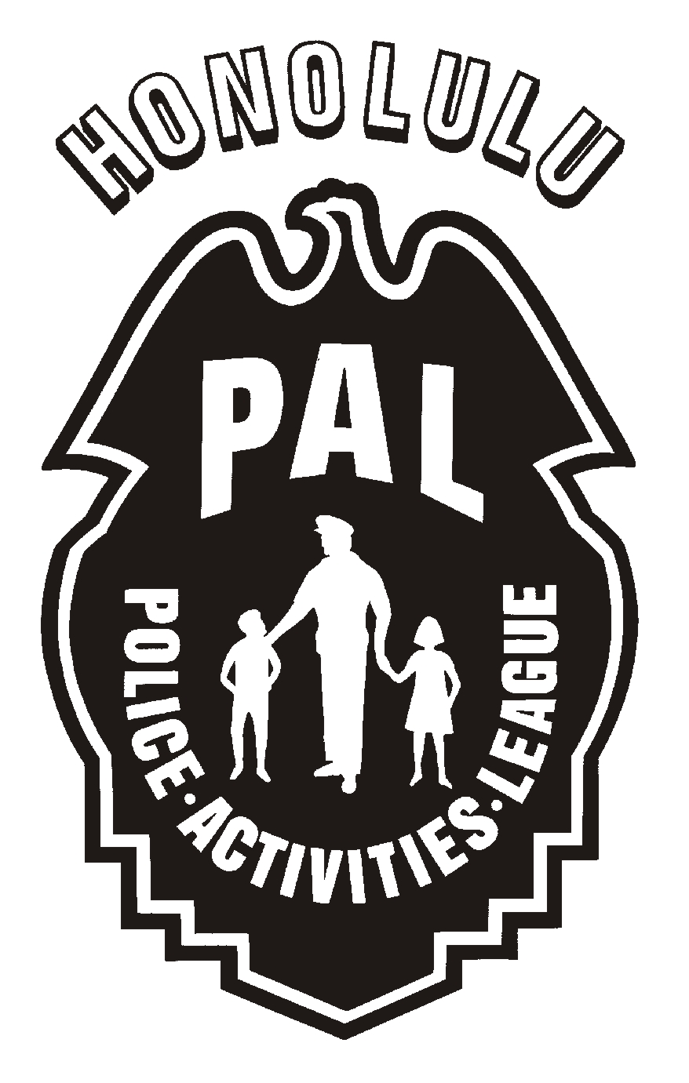


INFORMATION RELEASE WAIVER

AUTHORIZATION/PERMISSION
Please place a check mark next to your choice(s) and provide your personal information in the blank(s) provided:
I elect not to publish any information.

I am the authorized representative and I give permission to publish my club name. My

club name is: .

You may publish my e-mail address: .

You may publish my name: .

You may publish my phone number(s): .

I understand that the above listed information will be used to enhance communication and highlight the programs of the Honolulu Police Department’s Police Activities League (PAL). I understand that the information will be posted on the Internet (Worldwide Web) for the general public to view.
The information that is released will assist the PAL to inform the public about the available PAL programs within their communities. The public will be encouraged to contact the applicable athletic clubs or advisors within their area to obtain general information on sporting activities and registration dates.
I release the City and County of Honolulu, the Honolulu Police Department, and their officers, agents, employees, volunteers, and their successors, the Chief of Police, the Honolulu Police Commission, the Mayor, and the Honolulu City Council from any and all claims whatsoever, including without limitation, any and all claims of libel, invasion of privacy, or infringement of publicity rights in connection with the use of my name, my likeness, or my voice. I am the individual to whom the information applies.

Signature: .

Printed Name: . Date: .

If you have any questions about the collection or use of personal information, you may contact the Police Activities League supervisor at (808) 529-3881.

